LAB 1 - ITITIU22240 – Đàm Nguyễn Trọng Lễ  
Source code:  
Part 1:

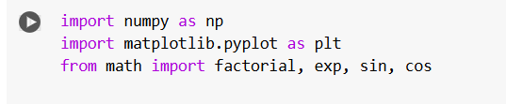  
Part 2:

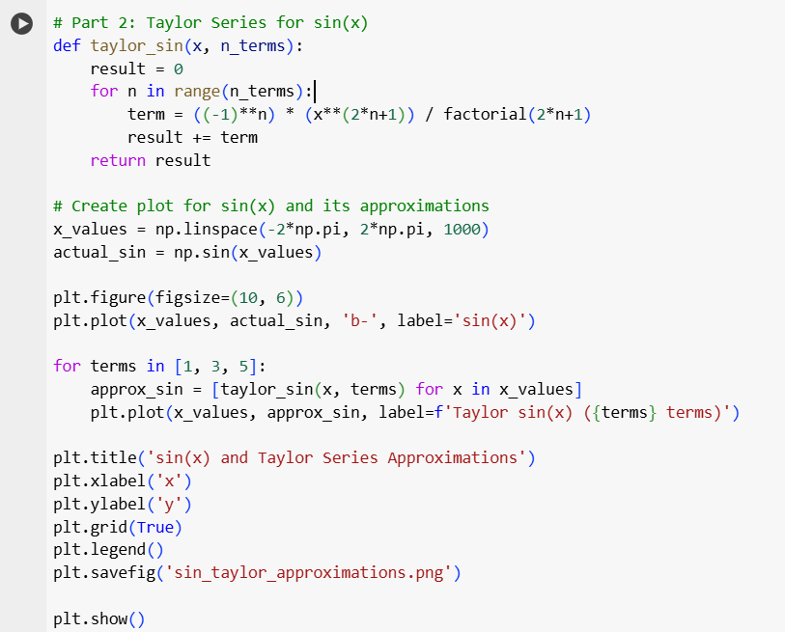  
Part 3:

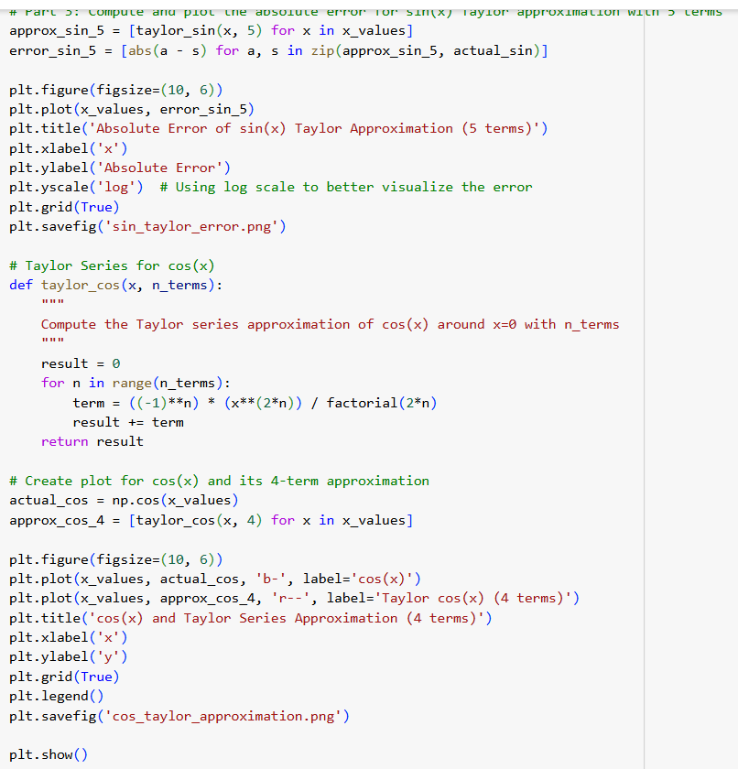

Result & analyze

Part 1:

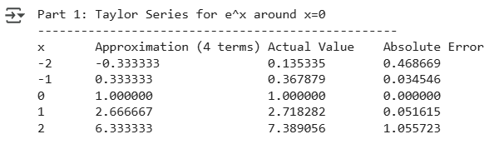

Part 2:

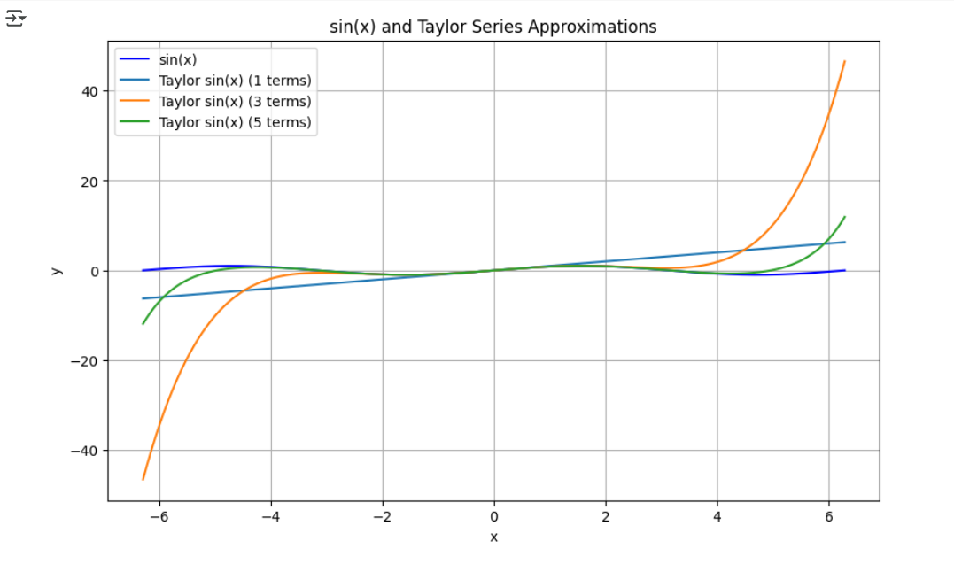

Part 3:

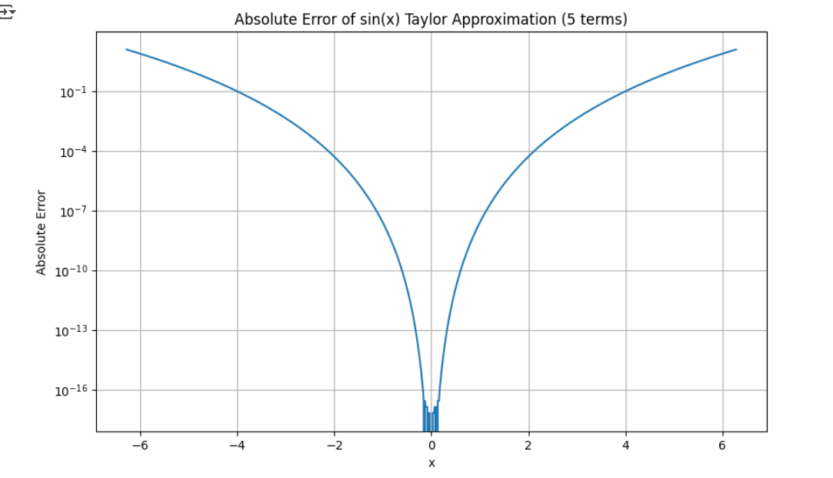

Based on the absolute error graph for the 5-term Taylor approximation of sin(x), the error is largest at the far ends of the domain, near x = -6 and x = 6.

This occurs because Taylor series approximations are centered around the expansion point (x = 0 in this case) and become less accurate as we move away from this point.

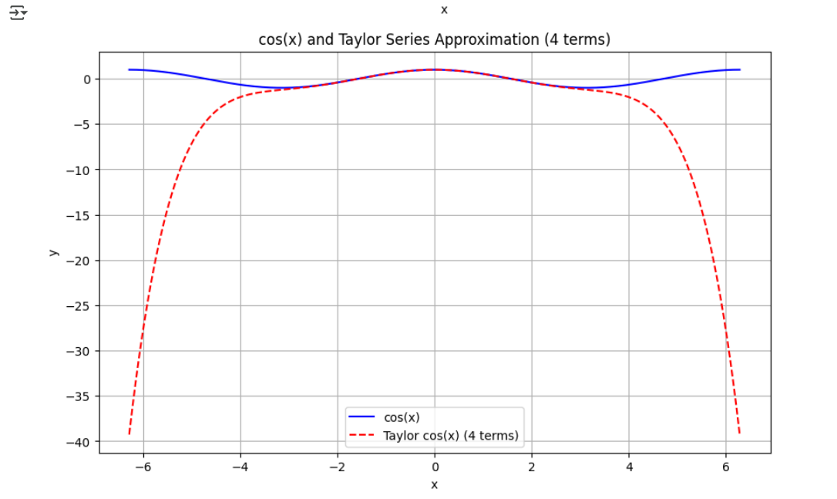

Compare the convergence of the Taylor Series for sin(x) and cos(x):

The Taylor series for both sin(x) and cos(x) show good approximation near x=0 (the center of expansion) but diverge as x moves away from this point. The cos(x) approximation with 4 terms shows drastic divergence beyond about x=±3, plummeting to negative values below -35. In contrast, the sin(x) approximation improves as we add terms - the 5-term approximation maintains reasonable accuracy over a wider range than the 3-term version, outperforms the 1-term approximation. The odd-degree terms in sin(x) and even-degree terms in cos(x) create different convergence behaviors, with cos(x) showing more dramatic divergence when using the same number of terms as sin(x). This is a reflecting of their respective symmetries, the sin(x) series involves odd powers of x, while the cos(x) series involves even powers.